**Exp. 1** : Design an LED FLASHER

**CIRCUIT DIAGRAM:**

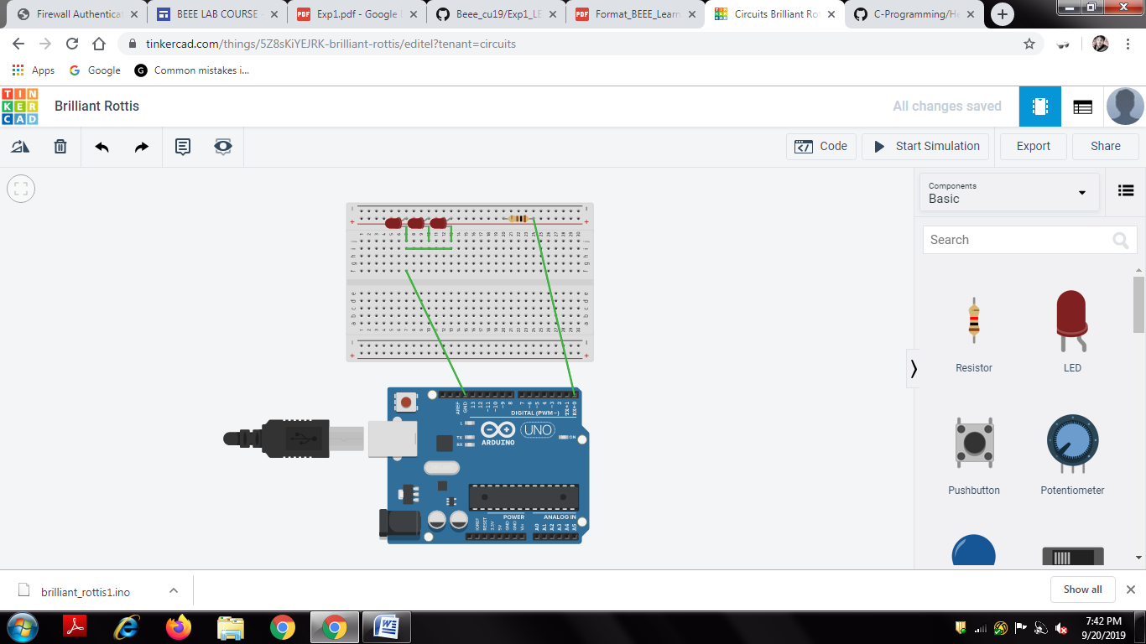

**CONCEPT USED:** It is as simple as turning a light on and off repeatedly. In this experiment I have attached 3 leds, which blinks all together.

**LEARNING AND OBSERVATIONS:**

By doing this experiment I came across many things like the basics of electronic components and their combinations forming a circuit.

**PROBLEMS AND TROUBLESHOOTING:**

I encounter a minor issue with programming the circuit as I later on clarified.

**PRECAUTIONS:**

These electrical components are delicate to handle.

Also the safety comes first when we are dealing with electric work.

Firstly I studied the experiment and learnt about the necessary knowledge required to perform the experiment.

**LEARNING OUTCOMES:**

It was my honour to do this experiment which made me aware of working of circuits specially with the Arduino.